**Calculating HD 189733 b Density using Transits and Radial Velocity Data**

*Kevin Hoy, Joshua Kingsbury, Avidaan Srivastava, Logan Steele*

1. **Motivation**

Modern technology has led to an explosion in the sample size of known exoplanets in recent years. As a result, there is a large shift towards understanding and categorizing planets, so they can be understood relative to the overall population. To this end, we have combined transit and radial velocity data to probe the mass and radius of HD 189733 b, which in turn allow us to calculate its density. These three parameters give us insight into the structure and nature of the planet. We selected this planet due to its apparently high radius and low period, which mean it has a very strong signal in both transit and radial velocity. This makes it an ideal candidate for demonstrating how these observations can translate to related unobservables we care about.

1. **Methods**

In order to calculate the density of the planet, we must discern both its radius and its mass. While neither of these properties are directly observable by modern methods, they are intrinsically related to measurements of their transits across the star and to the star’s radial velocity. We detail how these observations can be used to derive radius and velocity in the following subsections.

* 1. **Radial Velocity**

We used two different methods to obtain the planet mass from the radial velocity data: EXOFAST and direct, approximate calculation.

**2.1a EXOFAST**

EXOFAST is an online tool that accepts transit lightcurve and radial velocity data inputs, and returns model parameters for the planetary system. Combining radial velocity data and stellar properties, the code makes quick work of calculating a wide variety of parameters, including mass, period, semi-major axis, RV semi-amplitude, eccentricity, etc. The radial velocity data we used in this project came from Winn et al. (2006). Using this data, we produced a model that can be seen overlaying the actual data in Figure 1. Then, to further verify the accuracy of EXOFAST, we produced a Lomb-Scargle Periodigram (Figure 2) in order to determine the most likely period of our planet. Both agreed almost astonishingly well, only differing at the 5th decimal place, on a period of about 2.2 days. Results from EXOFAST will be discussed below, in Section 3.

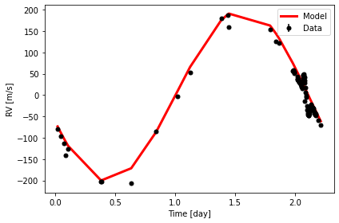

**Figure 1:** Radial Velocity as a function of time, featuring both the original data and the model fit calculated using EXOFAST parameters.

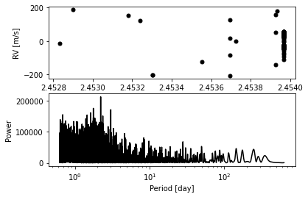

**Figure 2:** Lomb-Scargle Periodigram demonstrating the peak at the most likely period of 2.2 days

**2.1b Direct Calculation**

To derive the mass of the planet by hand, we again used radial velocity observations reported in Winn et al. (2006). From this data, we get two key observables: the semi-amplitude of the radial velocity and the period of the planet’s orbit. The semi-amplitude (K) is directly related to the mass of the planet, the mass of the host star, the semi-major axis of the orbit, and its inclination. Unfortunately, neither host star mass, semi-major axis, nor inclination are typically observable, making directly deriving mass more difficult. However, the star mass, orbital period, and semi-major axis are all intertwined due to Kepler’s Third Law, so it is possible to calculate them, and we use the star mass and semi major axis reported by TICv8, in Stassun et al. (2019), and Rosenthal et al. (2021), respectively. Inclination proves more difficult, having no corresponding observable, which gives rise to the parameter m sin *i*, which combines the mass and the inclination. Because our planet transits its star, we know that m sin *i* is very near the proper mass, as sin *i* is very near 1, but we do not eliminate it to maintain accuracy. Combining all of this yields the final equation:

$$m_{p}sini=K⋅m_{*}⋅\sqrt{\frac{a}{G m_{*}}} (1)$$

Using error propagation, we get that the corresponding error of this equation is given by:

$$σ_{m_{p}sini}=\frac{1}{2\sqrt{G}}\sqrt{K^{2}m_{*}\frac{σ_{a}^{2}}{a}+K^{2}a\frac{σ_{m_{*}}^{2}}{m_{*}}+4m_{*}aσ_{K}^{2}} (2)$$

Here, the errors in semi-major axis and star mass will be given by their sources, while the error in semi-amplitude comes from our calculation, and will be given by the equation:

$$σ_{K}=\frac{\sqrt{σ_{max}^{2}+σ_{min}^{2}}}{2} (3)$$

Where σmax and σmin are the errors in the maximum and minimum measured radial velocity, respectively.

* 1. **Transit**

To derive the radius of the planet, we used the transit light curve from Winn et al. (2007). The only feature we need from this curve is its depth, which is the difference between the amount of light we receive while there is no transit occurring, and the lowest flux we receive while the transit is occurring. This depth (δ) is related (almost) entirely to the ratio of the planet/star radii. Solving for the radius of the planet, the equation governing this interaction and its corresponding error are:

$$R_{p}=\sqrt{δ}R_{*} (4)$$

$$\frac{σ_{R_{p}}}{R_{p}}=\frac{σ_{δ}}{2δ}+\frac{σ_{R_{*}}}{R_{*}} (5)$$

The star radius and its error are both taken again from Rosenthal et al. (2021). We include an error in transit depth due to the effect on limb darkening on the lightcurve. Limb darkening makes the bottom of the transit appear to be curved as the planet transits across the star, even after the full area of the planet is blocking light. Figure 3 demonstrates this effect, as it is visible in both the data and the model fit we calculated that includes limb darkening parameters calculated with Pylightcurve. Limb darkening creates some ambiguity as to the true depth of the transit. To deal with this effect, instead of choosing a single point to represent the depth, we selected several points centered around the middle of the transit duration, and used their average as the lowest point and standard deviation as the error in this point. Since our data is normalized to one, the depth is thus given by the difference between one and this deepest point, while its error remains simply the error in this deepest point. These are what appear in equation 5.

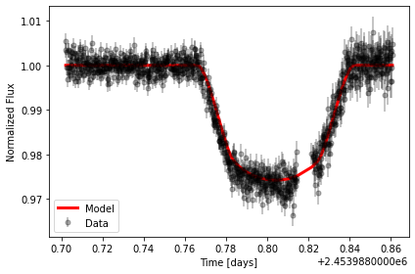

**Figure 3:** Transit light curve and model fit. You can see the effect of limb darkening with the continuous curvature of the bottom of the transit.

1. **Results**

Our primary goal in this project is to use real observational data to derive HD 189733 b’s mass (m sin *i* more accurately), radius, and density, so we can build a general picture of the planet’s structure. To derive the m sin *i*, we used radial velocity data with EXOFAST and equation 1. EXOFAST produced an m sin *i* of 1.156 MJ, while equation 1 & 2 give a value of 1.124 ± 0.016 MJ. Given our calculated errors, these values are marginally inconsistent with each other, but they remain very similar overall. They are also similar to the value of 1.13 ± 0.08 MJ reported in Stassun et al. (2017), which is highly consistent with our calculated value. We will use our own, hand-calculated value from here on, whenever it is necessary to invoke the mass.

As for the radius, using equations 4 & 5, we arrive at a value of 1.188 ± 0.069 RJ. This is again highly consistent with 1.13 ± 0.01 RJ from Stassun et al. We also compared our result to the mass-radius relation from Chen & Kipping (2016), which is given by the following equation:

$$R≈M^{-0.04} (6)$$

$$σ_{R}=R*0.04*\frac{σ_{M}}{M} (7)$$

This gives a radius of 0.9953 ± 0.0006 RJ, which again differs significantly from our calculation based on the light curve, but is still of the correct order of magnitude, at least.

Finally, to calculate the density, we combine our calculated mass and radius in the equations:

$$ρ=\frac{M}{\frac{4}{3}πR^{3}} (8)$$

$$σ_{ρ}=ρ*\left(\frac{σ_{M}}{M}+3\frac{σ_{R}}{R}\right) (9)$$

The resulting density is 832.087 ± 156.175 kg/m3. This is consistent with the literature value of 943 (+81, -72) kg/m3. We then plotted our density with those planets in NEA’s database that have a reported mass and radius, using equations 8 & 9 to derive their densities. These are shown in figure 4.

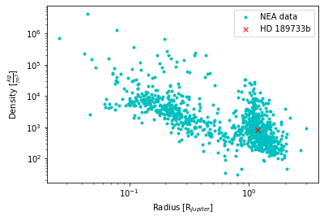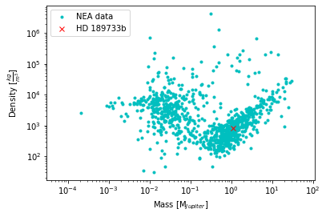

**Figure 4:** Density vs Radius & Density vs. Mass, comparing HD 189733 b to other planets in NEA’s database

1. **Conclusion**

HD 189733 b, with a radius of 1.188 ± 0.069 RJ, m sin *i* of 1.124 ± 0.016 MJ, and density of 832.087 ± 156.175 kg/m3, is firmly in the camp of a Jovian planet. With a period of only 2.2 days, it more specifically falls into the category of a Hot Jupiter. Our calculations also fit fairly well with the relation given in Chen & Kipping (2016).

1. **Contributions**

This report was done in collaboration by Kevin Hoy, Joshua Kingsbury, Avidaan Srivastava and Logan Steele. The work was divided amongst the members and the project was completed together as a team. The specific contributions of each member of the team are listed below:

*Kevin Hoy:* Writing of the report.  
*Joshua Kingsbury:* Class presentation.  
*Avidaan Srivastava:* Transit analysis, density calculations/plots.  
*Logan Steele:* Radial velocity analysis

1. **References:**

Chen, J., & Kipping, D. 2016, The Astrophysical Journal, 834, 17, doi: 10.3847/1538-4357/834/1/17

Rosenthal, L. J., Fulton, B. J., Hirsch, L. A., et al. 2021, ApJS, 255, 8, doi: 10.3847/1538-4365/abe23c

Stassun, K. G., Collins, K. A., & Gaudi, B. S. 2017, AJ, 153, 136, doi: 10.3847/1538-3881/aa5df3

Stassun, K. G., Oelkers, R. J., Paegert, M., et al. 2019, AJ, 158, 138, doi: 10.3847/1538-3881/ab3467

Winn, J. N., Johnson, J. A., Marcy, G. W., et al. 2006, ApJL, 653, L69, doi: 10.1086/510528

Winn, J. N., Holman, M. J., Henry, G. W., et al. 2007, AJ, 133, 1828, doi: 10.1086/512159448